Game Concept 1

* A tile facing in all directions is automatically placed in the centre
* A starting player is randomly chosen
* A “Next Tile” is randomly chosen
* This tile can only be placed such that the white lines connect
* Valid places for the tile to go are marked by the green tiles
* The player whos turn it currently is taps one of the green squares to place the “Next Tile” there
* The turn switches to the other player and another “Next Tile” is generated
* The goal for each player is to get the majority of the available points
* A point is gained when a player connects the network to one of the golden tiles. This tile then becomes a normal tile.
* These golden tiles are placed randomly around the map

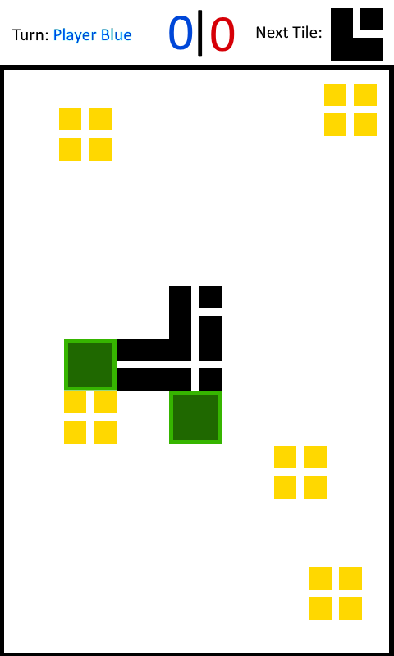

Game Concept 2

* This concept is identical to Game Concept 1, but with a different goal
* The goal for each player is to connect the network to the tile in the corner that matches their colour
* The first player to do this wins

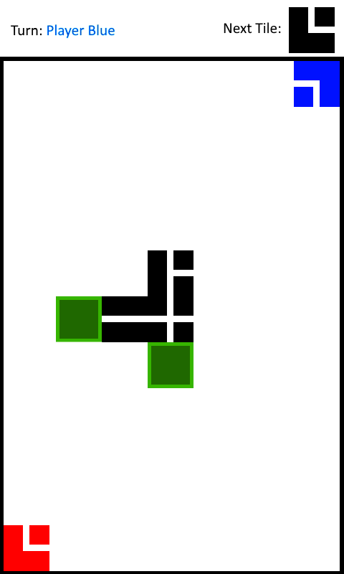

Game Concept 3

* This concept is identical to Game Concept 1, but with a different goal
* The goal for each player is to connect the network to the golden tile at the top of the screen.
* The first player to do this wins

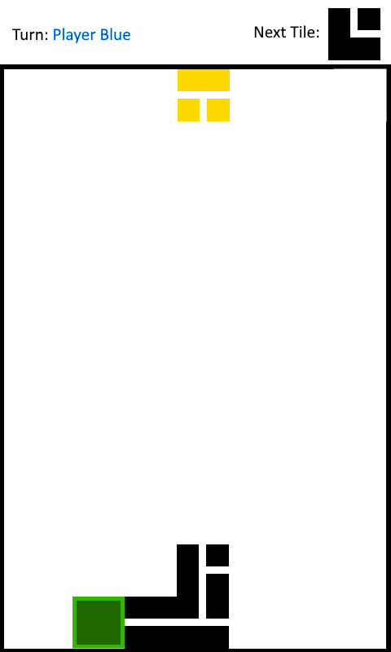

Game Concept 4

* Players take turns to fire shots from a cannon that rotates left and right constantly
* These shots bounce off of walls
* There are 4 targets moving side-to-side within the level
* The goal is for the players to destroy all the targets
* The player to destroy the last targets wins
* In effect, this would work very similarly to the following minigame from “Enter the Gungeon”: https://www.youtube.com/watch?v=pNA10-zSdsw